**MIDRAND CONFERENCE CENTRE**

**A world class conference centre in the heart of Midrand!**

* Just 3 minutes from the Allandale turnoff
* 5 Minutes from the New Road offramp
* Over the road from the Gallagher Estate
* 5 Minutes from the Mall of Africa precinct
* 8 Minutes from the Linbro Office Park
* 15 Minutes from Sandton City

**Click here or call Tracey on 082 397 6689 for more information or to book your next conference** 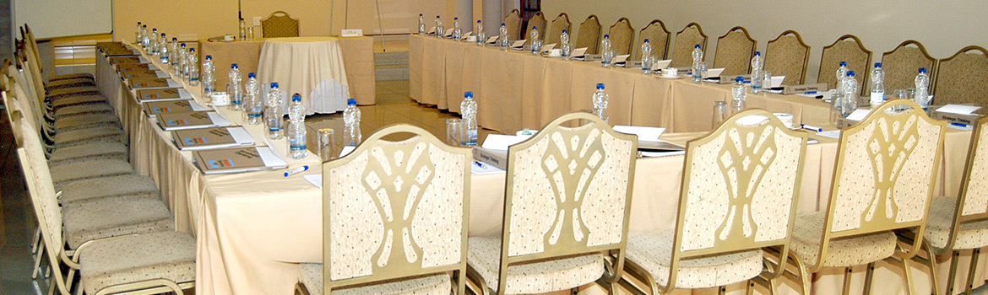

**Our conference centre would be top class in any location!**

* With 15 conference rooms ranging from 700 seats to 10 seats
* We also provide top class catering
* On-site accommodation
* Snappy and friendly service
* A desire to meet your specific needs
* Experienced conference co-ordinators will make your conference a successful and memorable one

**Click here or call Tracey on 082 397 6689 for more information or to book your next conference**